TERMS OF REFERENCE

Upgrading the Controlled Environment Facility with an Internet of Things (IOT) Based Control and Monitoring System

(Ref No:/RA3/DOR/RUSL/AGRI/DPS/OVAA/18)
(RuCeF – Glasshouse)
Faculty of Agriculture, Rajarata University of Sri Lanka

PURPOSE OF THE PROJECT

Our aim is to study the effects of rising air temperatures on the growth and functioning of agricultural crops and other plants inside a controlled environment facility. Inside the facility, future climatic extremes as mentioned below will be simulated.

LOCATION

The project site is Faculty Farm Premises, Faculty of Agriculture, Rajarata University of Sri Lanka, Puliyankulama, Anuradhapura.

BUILDING SPECIFICATIONS

- There are three glasshouse units (5×5 m). The roof height is 3.7 m at the gutter ends.
- The walls of these units are covered with 5 mm thick glass.
- There is 1.5×2 m concrete pavement outside each unit where heat pumps of air conditioners are installed.
- The roof of the glasshouse has two layers made from 6 mm tempered glass to reduce incoming heat load by leaving a 12 cm thick air layer sandwiched between two glass layers.
- At the central connection of the top glass layer, a top vent is fitted with an exhaust fan to facilitate the convective cooling from the lower glass roof.
- Engineering drawings of these units are attached (Attachment 01).

ENVIRONMENT CONTROL REQUIREMENTS

Temperature

- Temperature control and simulation is the main experimental variable of the experiment.
- The temperature settings prescribed below should be maintained as accurately and precisely as possible.
- To satisfy the thermal load of each glasshouse chamber four units of 24000 BTU air conditioners are installed per glasshouse chamber, which can be used for cooling requirements.
- Two heating units per glasshouse chamber are installed for heating.

Ambient values

- Use sensors placed at least 10 m away from the glasshouse as well as in a portable unit should to log and sense the real-time ambient temperature and relative humidity.
- Designers/bidders should account for both the diurnal and annual variation of these values in the project site in Puliyanulama, Anuradhapura (see Figure 1 below).

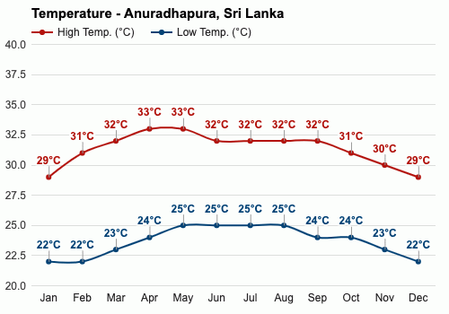

Figure 1. Annual variation in minimum and maximum temperature in Anuradhapura. Please note that during April-August period, the maximum can be much higher than this. There can be cases reporting 36, 37, 38°C. Therefore, the upper end of the ambient could be as high as 38°C in some days.

Relative Humidity

- As for the temperature, the RH need be monitored and logged in both inside and outside the glasshouse and well as in a portable device using sensors.
- RH needs to be controlled using appropriate combinations of humidifiers and dehumidifies.
- Bidders should account for the tri-way relationship of temperature, relative humidity and dew point (see Figure 2 below) and to avoid fog/dew formation.

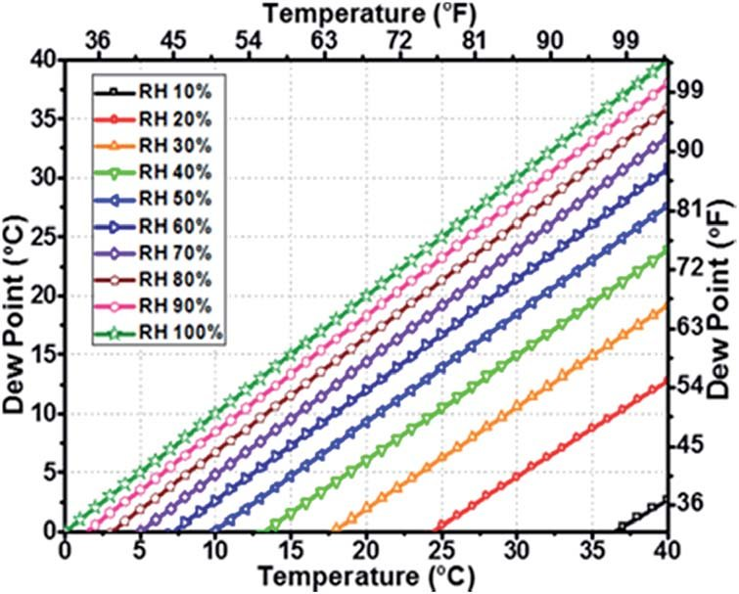
Figure 2. Dew point at various temperatures and relative humidity.

- The lowest extreme would be 60% and the highest would be 80%. Too much dehumidification may lead to reduce RH below 60% leading to excessive water loss from plants. Likewise, excessive humidification over 80% will lead to fog formation, diseases in crops, and malfunction of data loggers, sensors and other scientific equipment.
- When crops are grown inside, they will transpire water vapor and contribute to about 5% increase in RH during the day time.

MODES OF OPERATION

The hardware and software solution proposed should allow the user to operate the system in following modes.
- Stationary ambient
- Portable ambient
- Set formula
- Troubleshooting

Stationary Ambient
- In this mode, users should be able to set a dynamic temperature and relative humidity settings compare to the ambient temperature and relative humidity values measured from the sensors placed outside of the glasshouse (stationary ambient sensors).
- The users should be able to set an increment or decrement of relative humidity and temperature at 0.1 levels. This increment or decrement should be able to set relative to the respective readings from the stationary ambient.

Portable Ambient
- In this mode, a portable device should be designed and built to sense and send temperature and relative humidity of the location where the portable device is placed.

Set Formula
- In this mode the temperature and relative humidity values should able to set as fix value without any reference to the portable and ambient values receiving from the sensors.

Troubleshooting
- All the equipment inside each glasshouse chamber should be able to manually turn on or off for various troubleshooting requirements.

GRAPHICAL USER INTERFACES

Web System
- All the three chambers should be able to independently work and controllable using a web system.
- The above configurations should be fully controllable using a web system that connect sensors, controllers, web server and other requirements to the user.
- Main architecture includes the login page, dashboard, settings page and data download pages
- Dashboard
  - Readings from individual sensors, their averages including real-time graphical illustrations
  - Operation modes
  - Status of equipment
- Settings
  - Change the operation modes
  - Set increments and decrements of temperature and relative humidity for each chamber
  - Status of the controllers and equipment
- Download files
  - Filtering options by dates

Android App
- An Android app should be developed to operate, monitor and control each glasshouse chamber
- The options available in the web-system should be simultaneously available and functional in the app

OTHER REQUIREMENTS

- In case of power failure, all environment control units should turn on automatically after turning on the electricity generator or return of power to the main grid. In such a situation, the last set temperature and relative humidity configuration should automatically resume.
- Critical or abnormal conditions in the glasshouse need to be indicated through app notifications.
- Data should be securely stored in a reliable data server. The web system should not be openly available for public viewing.
- Installations should be properly labeled, housed in industrial housing.
- Abnormal readings should be self-diagnosed and rectified before implementing system controls and data logging.
- All the sensors should be tested before soldering to their maximum and minimum readings of temperature and relative humidity.
- The bidders should provide at least two-year free service and warranty for software and hardware components.
- Proof of experience for conducting similar or allied works should be submitted together with the proposals.

AVAILABLE HARDWARE

- Four 24000 BTU air conditioners per chamber
- One roof mounted exhaust fan per chamber
- Two heaters per chamber
- One pump coupled to two foggers per chamber
- Proxy free Dialog 4G connection power with an uninterrupted power supply
- Three-phase CEB electricity and automated electricity generator (Diesel Generator 60KVA)
- Electricity cabling system inside the glasshouse in each chamber with heavy-duty 13A plug bases (e.g. 4 per chamber e on side walls across the four side walls) to couple machines and devices within each chamber.
- Each chamber with four large LED lights
- Corridor with High Power LED 20W minimum with screw connectors.
- A distribution board with heavy-duty housing with appropriate MCBs, isolators and ground wire.
- 8-camera CCTV security system with day and night functionality and Infrared Range of a minimum of 20 meters, LCD display, 1 TB DVR

CLARIFICATIONS AND SITE VISITS

- To arrange site visits and obtain any clarifications, bidders may consult with the Project Coordinator, Dr. Nalaka Geekiyanage, Faculty of Agriculture, Rajarata University of SL (P: +94 252 22 16 11M: +94714 66 00 48F: +94 252 22 16 11, E: nalaka.geekiyanage@agri.rjt.ac.lk)

